[FULL PAPER TITLE: CONCISE, SPECIFIC, AND INFORMATIVE]
First Author^{1,*}, Second Author², and Third Author¹
¹ Department/Study Program, Faculty, Institution, City, Country
² Department/Study Program, Faculty, Institution, City, Country
*Corresponding author: author@institution.ac.id
ABSTRACT
[Write a structured, single-paragraph abstract of 200–300 words in English covering background, objective, method, principal results, and conclusion/implication. Do not include citations, tables, figures, equations, or undefined abbreviations.]
Keywords: three to five keywords or short phrases; separated by semicolons
Conference scope: [select one most relevant ICOTENS scope]
1. INTRODUCTION
[Explain the broader context, urgency, and scientific or practical problem; synthesize the current state of knowledge using relevant primary literature; identify the unresolved research gap; and show why the gap matters. State the research objective, question, or hypothesis clearly and explain the expected theoretical, methodological, empirical, or practical contribution. Avoid presenting references as an unconnected list. End the section with a concise transition to the research method.]
2. MATERIALS AND METHODS
2.1 Research Design, Data, and Materials
[Describe the research design, location and period, population and sample or data sources, inclusion and exclusion criteria, instruments, materials, variables, and data-collection procedure. State the source, resolution, period, and format of secondary or remote-sensing data when applicable.]
2.2 Processing and Analytical Procedure
[Explain preprocessing, experimental stages, algorithms or models, parameter settings, software and versions, validation strategy, comparison or baseline methods, and statistical tests. Include equations only when necessary, define every symbol, and number equations sequentially.]
2.3 Quality Control and Validation
[Describe reliability, validity, calibration, sensitivity analysis, reproducibility controls, bias mitigation, and the criteria used to evaluate or compare results.]
3. RESULTS AND DISCUSSION
[Present the principal findings in a logical sequence. Interpret the results, compare them with prior studies, explain agreements or differences, discuss theoretical and practical implications, and state relevant limitations. Avoid repeating all numerical values from tables in the text.]
As illustrated in Figure 1, the research process should be presented as a clear and reproducible sequence from data collection to interpretation.
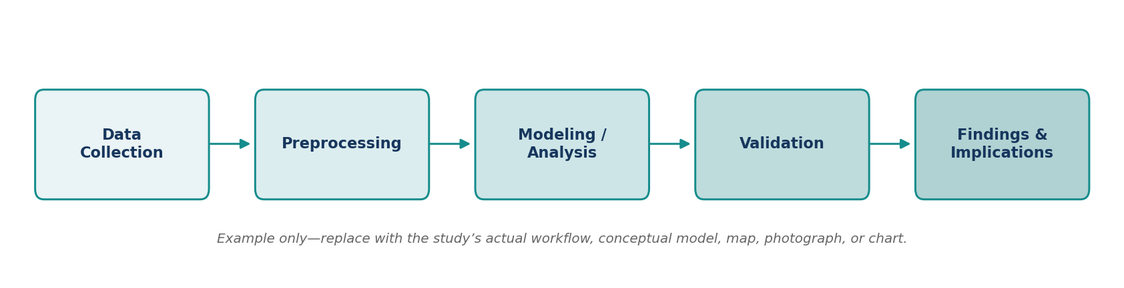
Figure 1. Example of a research workflow diagram. Replace this figure with the author’s original figure.

Table 1. Concise table title placed above the table.
Variable/Category | Group or Period 1 | Group or Period 2
[Item 1] | [Value] | [Value]
[Item 2] | [Value] | [Value]
[Item 3] | [Value] | [Value]
Note: Define abbreviations and statistical symbols below the table when needed.
[Continue the Results and Discussion with a concise narrative explaining the patterns shown in the figure and table. Report the most important values, uncertainty, statistical significance, or model-performance indicators, but do not repeat every number already displayed.]
[Interpret the findings in relation to the research objective and compare them critically with relevant previous studies. Explain possible mechanisms, agreements or differences, scientific and practical implications, and limitations that directly affect interpretation.]
4. CONCLUSION
[State the main conclusion directly in relation to the objective. Emphasize the study contribution and implications without repeating the abstract or introducing new results. Add concise recommendations, implementation considerations, or future research directions when justified by the evidence.]
ACKNOWLEDGMENTS
[Acknowledge individuals, institutions, facilities, or assistance that do not meet authorship criteria. Delete this section if not applicable.]
REFERENCES
Arrange references alphabetically using APA 7th edition unless the selected publication outlet requires another style. Every in-text citation must appear in the reference list and vice versa.
Author, A. A., & Author, B. B. (2025). Title of article. Journal Name, 12(3), 101–115. https://doi.org/xx.xxxx/xxxxx
Author, A. A. (2024). Title of book (2nd ed.). Publisher.
Author, A. A. (2025). Title of paper. In Proceedings of Conference Name (pp. 10–18). Publisher. https://doi.org/xx.xxxx/xxxxx
Organization Name. (2025). Title of report. URL

AUTHOR GUIDELINES
Full Paper Submission • 2nd ICOTENS 2026
FULL PAPER FORMATTING REQUIREMENTS
Element | Font / size | Style
Paper | A4; margins 2.5 cm | Portrait; one-column layout
Title | Times New Roman, 14 pt | Bold, uppercase, centered
Authors | Times New Roman, 10.5 pt | Bold, centered
Affiliations/email | Times New Roman, 8.5 pt | Italic, centered
Abstract/keywords | Times New Roman, 10 pt | Single spacing; justified
Main headings | Times New Roman, 11 pt | Bold, uppercase, left
Body text | Times New Roman, 10 pt | Justified; single spacing; 0.7 cm first indent
Figure/table captions | Times New Roman, 8.5 pt | Figure below; table above
References | Times New Roman, 9 pt | APA 7th; hanging indent
Recommended full-paper length: 6–10 A4 pages, including figures, tables, and references.
File name: ICOTENS2026_FullPaper_FirstAuthorName_Institution.docx
IMPORTANT DATES
Full paper submission deadline | 15 October 2026
Conference day | 31 October 2026
Revised selected full paper deadline | 15 November 2026
Publication process | November 2026–February 2027
CONTACT INFORMATION
Website | https://icotens-fmipa.unpak.ac.id/
Email | icotens@unpak.ac.id
Contact person | Siska Andriani • WhatsApp +62 812 9135 4442

